Task 1: Deploy a CloudFormation Stack
AWSTemplateFormatVersion: 2010-09-09
Description: Lab template

# Lab VPC with public subnet and Internet Gateway

Parameters:

LabVpcCidr:
Type: String
Default: 10.0.0.0/20

PublicSubnetCidr:
Type: String
Default: 10.0.0.0/24

Resources:

###########
# VPC with Internet Gateway
###########

LabVPC:
Type: AWS::EC2::VPC
Properties:
CidrBlock: !Ref LabVpcCidr
EnableDnsSupport: true
EnableDnsHostnames: true
Tags:
- Key: Name
Value: Lab VPC

IGW:
Type: AWS::EC2::InternetGateway
Properties:
Tags:
- Key: Name
Value: Lab IGW

VPCtoIGWConnection:
Type: AWS::EC2::VPCGatewayAttachment
DependsOn:
- IGW
- LabVPC
Properties:
InternetGatewayId: !Ref IGW
VpcId: !Ref LabVPC

###########
# Public Route Table
###########

PublicRouteTable:
Type: AWS::EC2::RouteTable
DependsOn: LabVPC
Properties:
VpcId: !Ref LabVPC
Tags:
- Key: Name
Value: Public Route Table

PublicRoute:
Type: AWS::EC2::Route
DependsOn:
- PublicRouteTable
- IGW
Properties:
DestinationCidrBlock: 0.0.0.0/0
GatewayId: !Ref IGW
RouteTableId: !Ref PublicRouteTable

###########
# Public Subnet
###########

PublicSubnet:
Type: AWS::EC2::Subnet
DependsOn: LabVPC
Properties:
VpcId: !Ref LabVPC
MapPublicIpOnLaunch: true
CidrBlock: !Ref PublicSubnetCidr
AvailabilityZone: !Select
- 0
- !GetAZs
Ref: AWS::Region
Tags:
- Key: Name
Value: Public Subnet

PublicRouteTableAssociation:
Type: AWS::EC2::SubnetRouteTableAssociation
DependsOn:
- PublicRouteTable
- PublicSubnet
Properties:
RouteTableId: !Ref PublicRouteTable
SubnetId: !Ref PublicSubnet

###########
# App Security Group
###########

AppSecurityGroup:
Type: AWS::EC2::SecurityGroup
DependsOn: LabVPC
Properties:
GroupName: App
GroupDescription: Enable access to App
VpcId: !Ref LabVPC
SecurityGroupIngress:
- IpProtocol: tcp
FromPort: 80
ToPort: 80
CidrIp: 0.0.0.0/0
Tags:
- Key: Name
Value: App

###########
# Outputs
###########

Outputs:

LabVPCDefaultSecurityGroup:
Value: !Sub ${LabVPC.DefaultSecurityGroup}

Look through the file. You will notice several sections:
- The Parameters section is used to prompt for inputs that can be used elsewhere in the template. The template is asking for two IP address (CIDR) ranges for defining the VPC.
- The Resources section is used to define the infrastructure to be deployed. The template is defining the VPC, and a Security Group.
- The Outputs section is used to provide selective information about resources in the stack. The template is providing the Default Security Group for the VPC that is created.
The template is written in a format called YAML, which is commonly used for configuration files. The format of the file is important, including the indents and hyphens. CloudFormation templates can also be written in JSON.
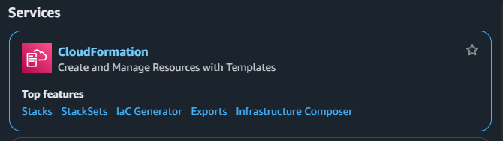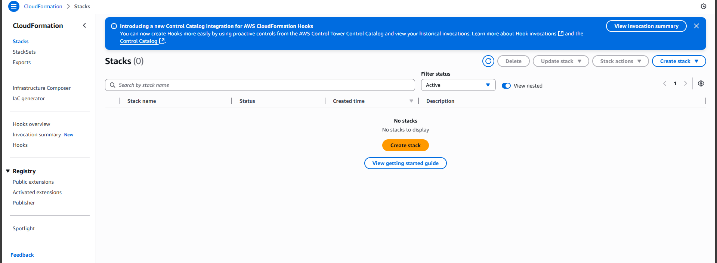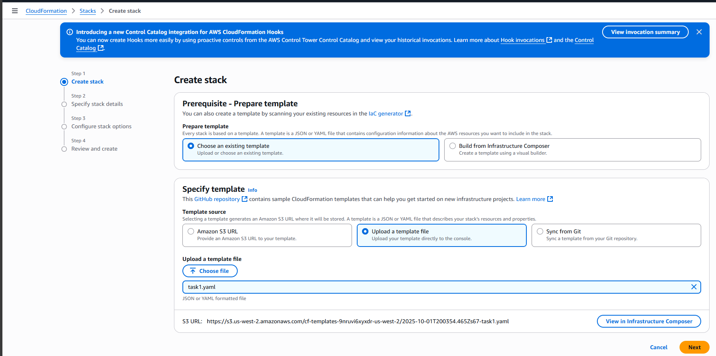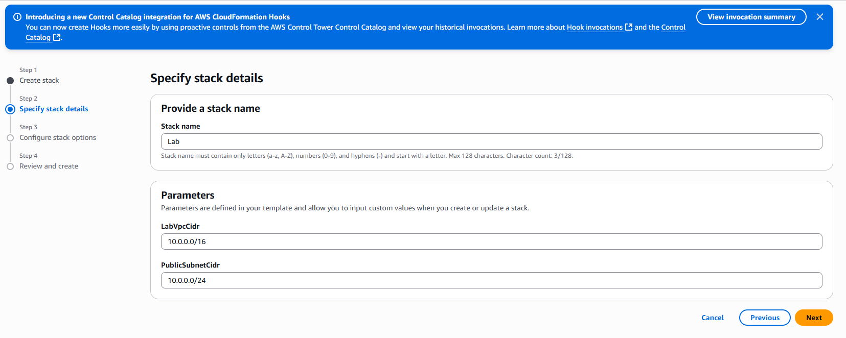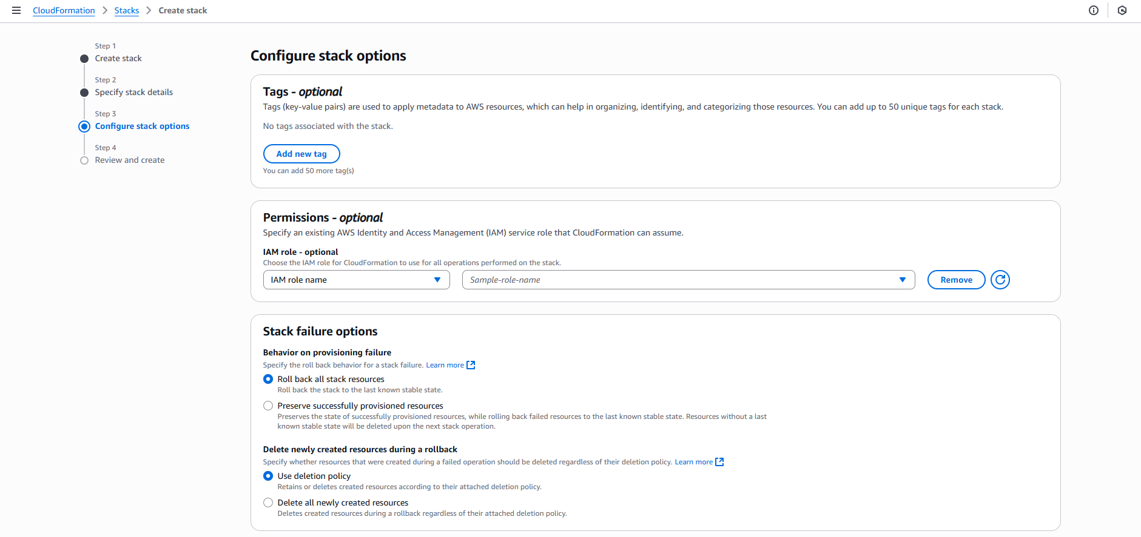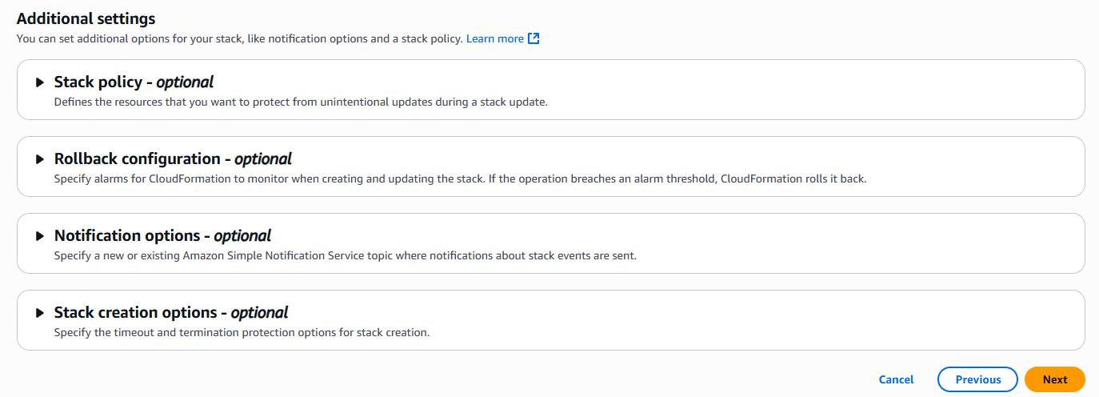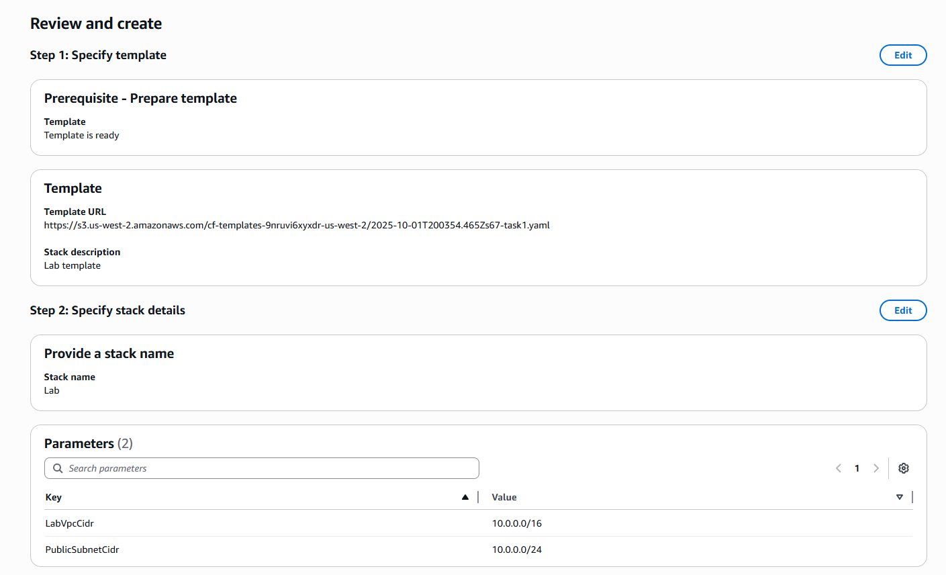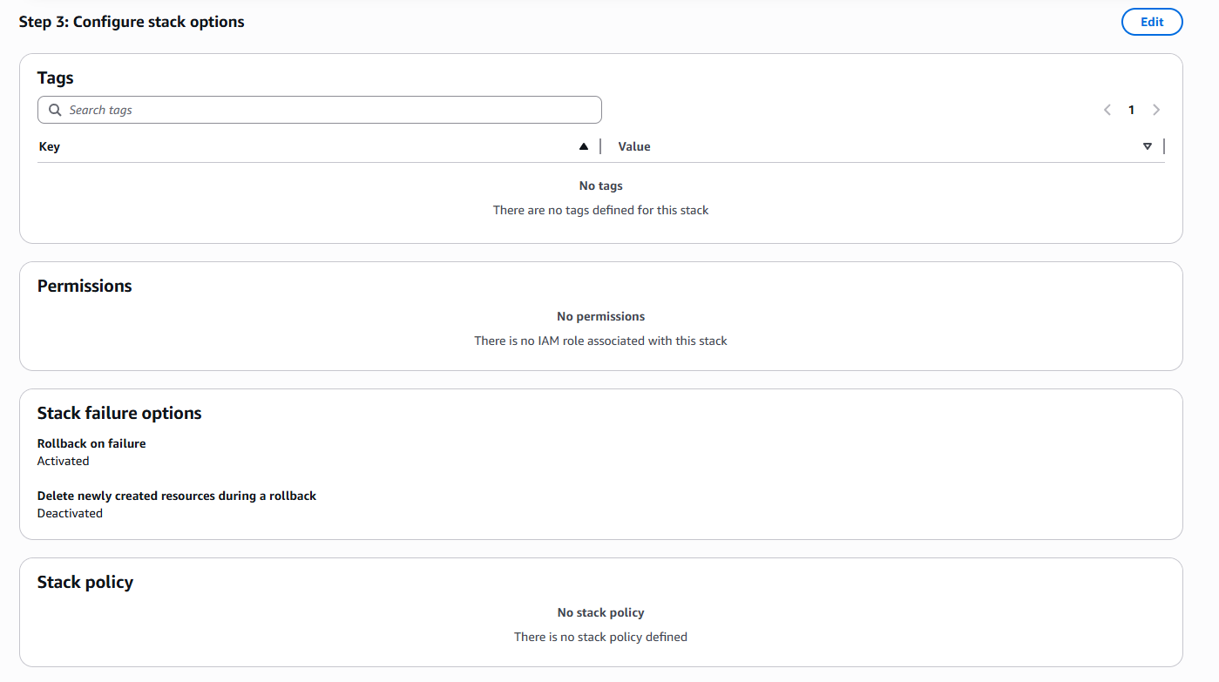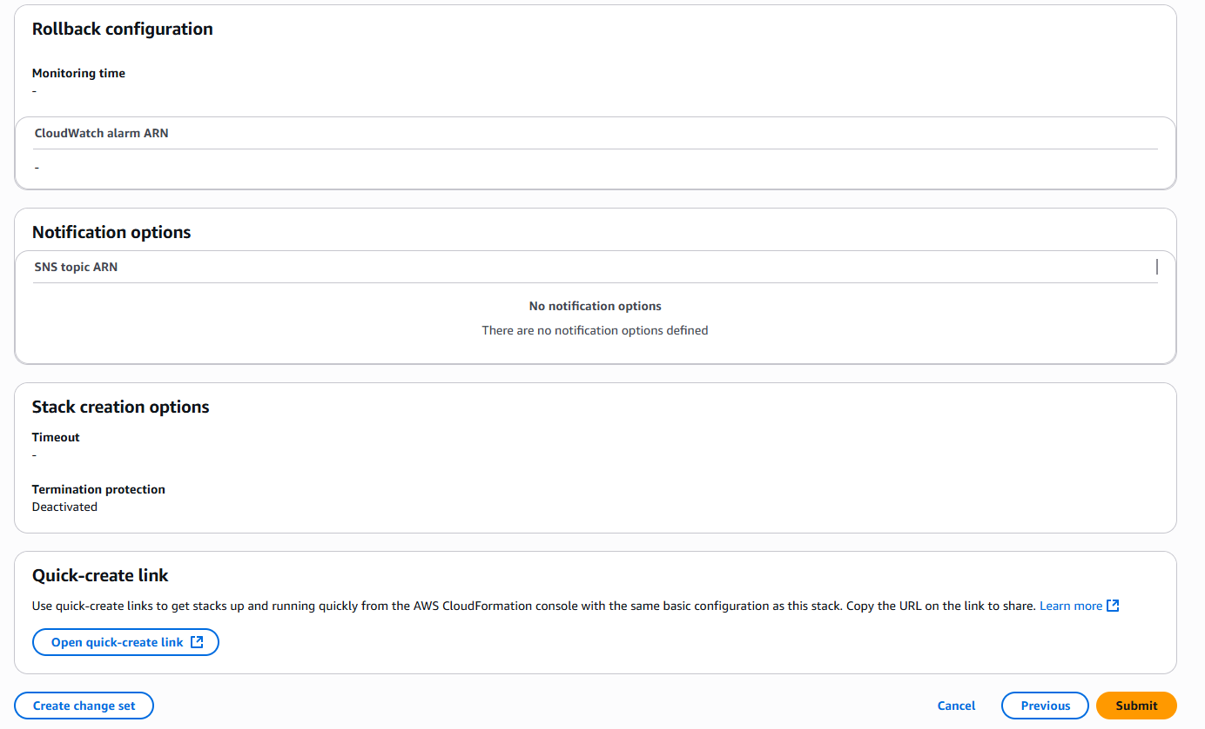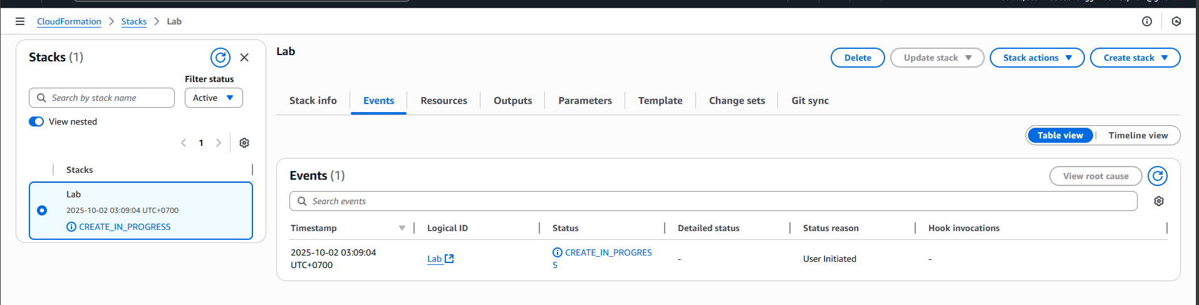
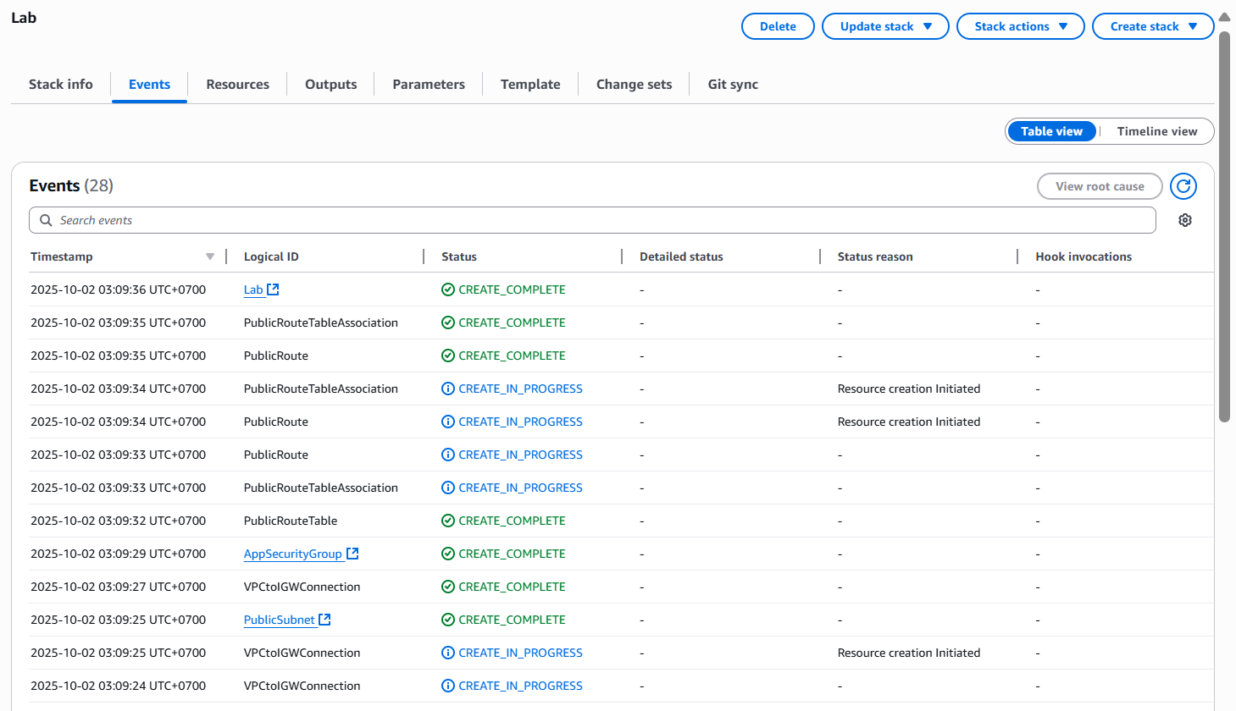

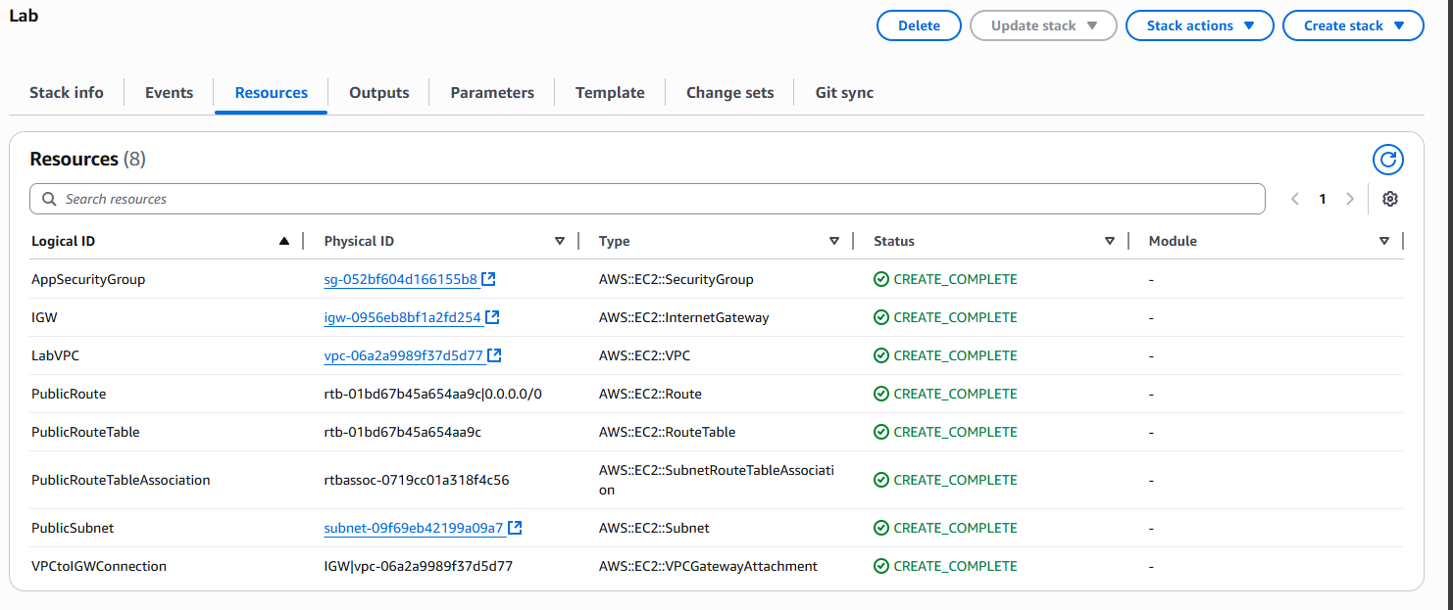
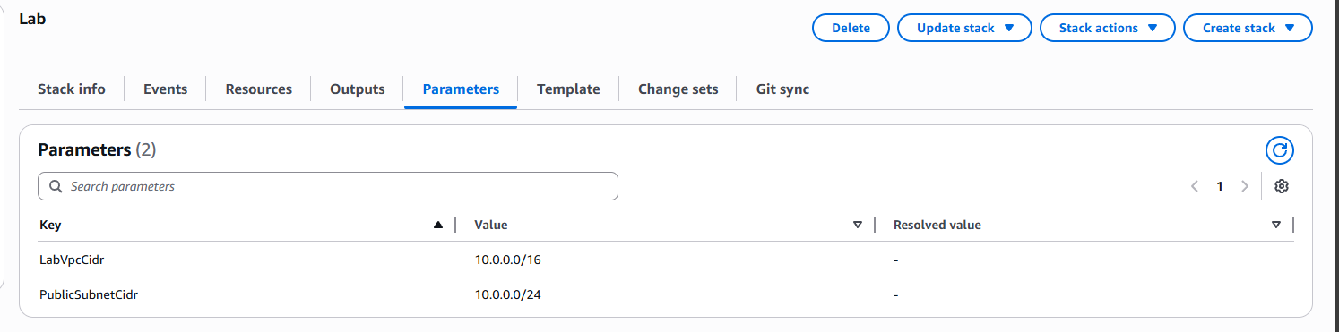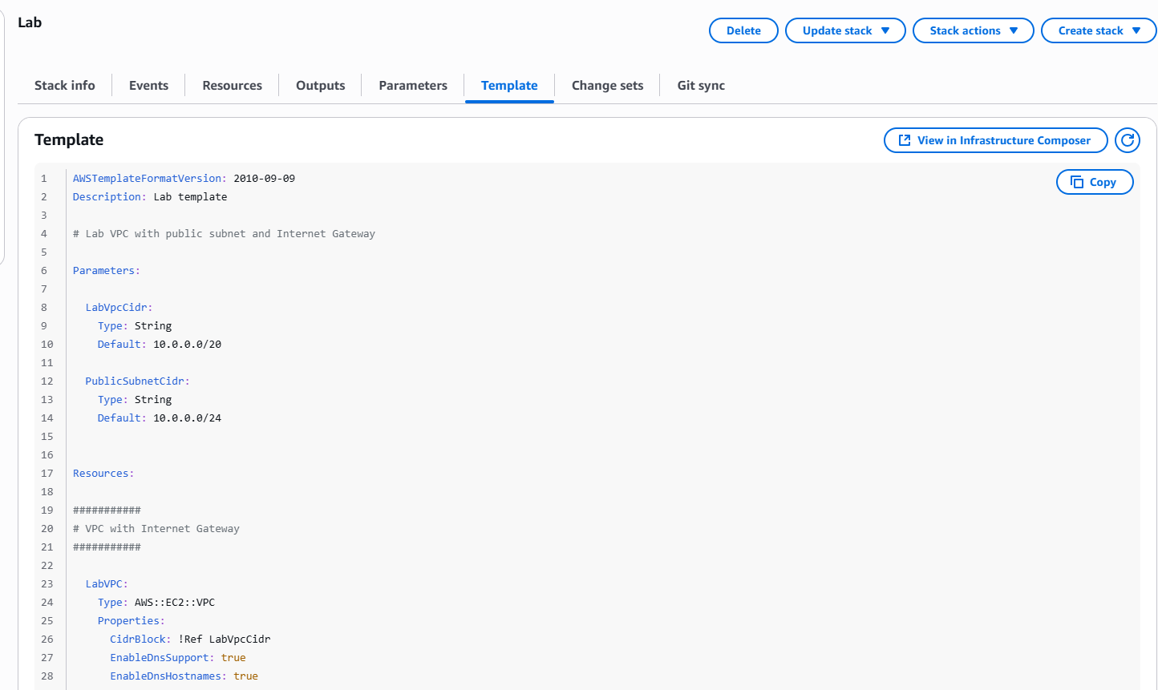
Sample Hasil
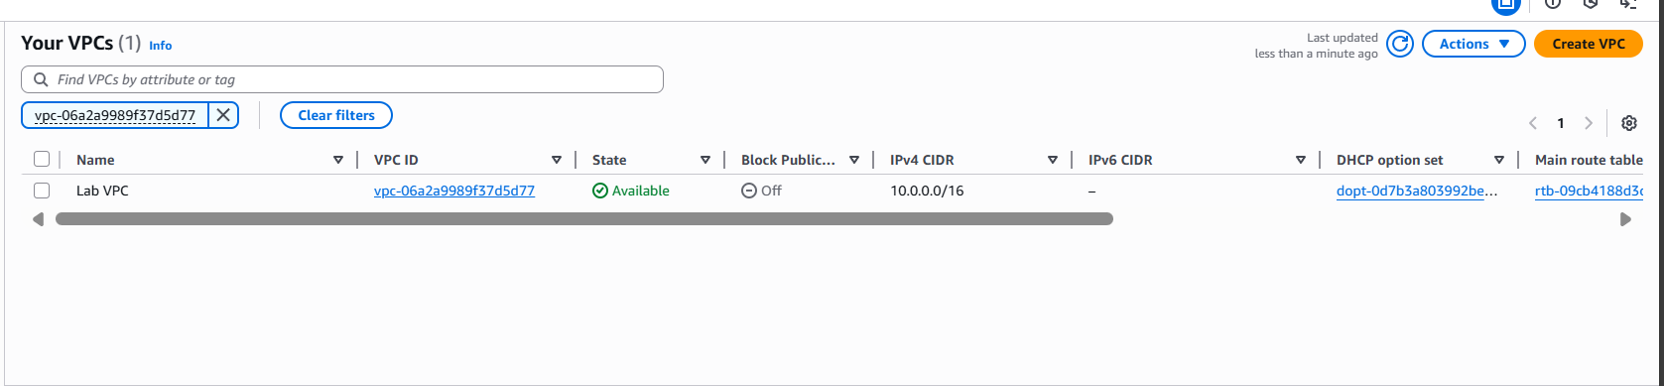
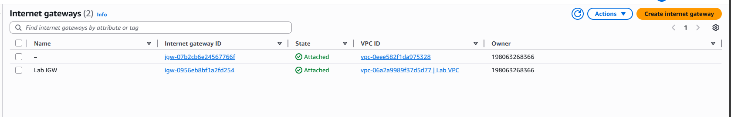
Task 2: Add an Amazon S3 Bucket to the Stack
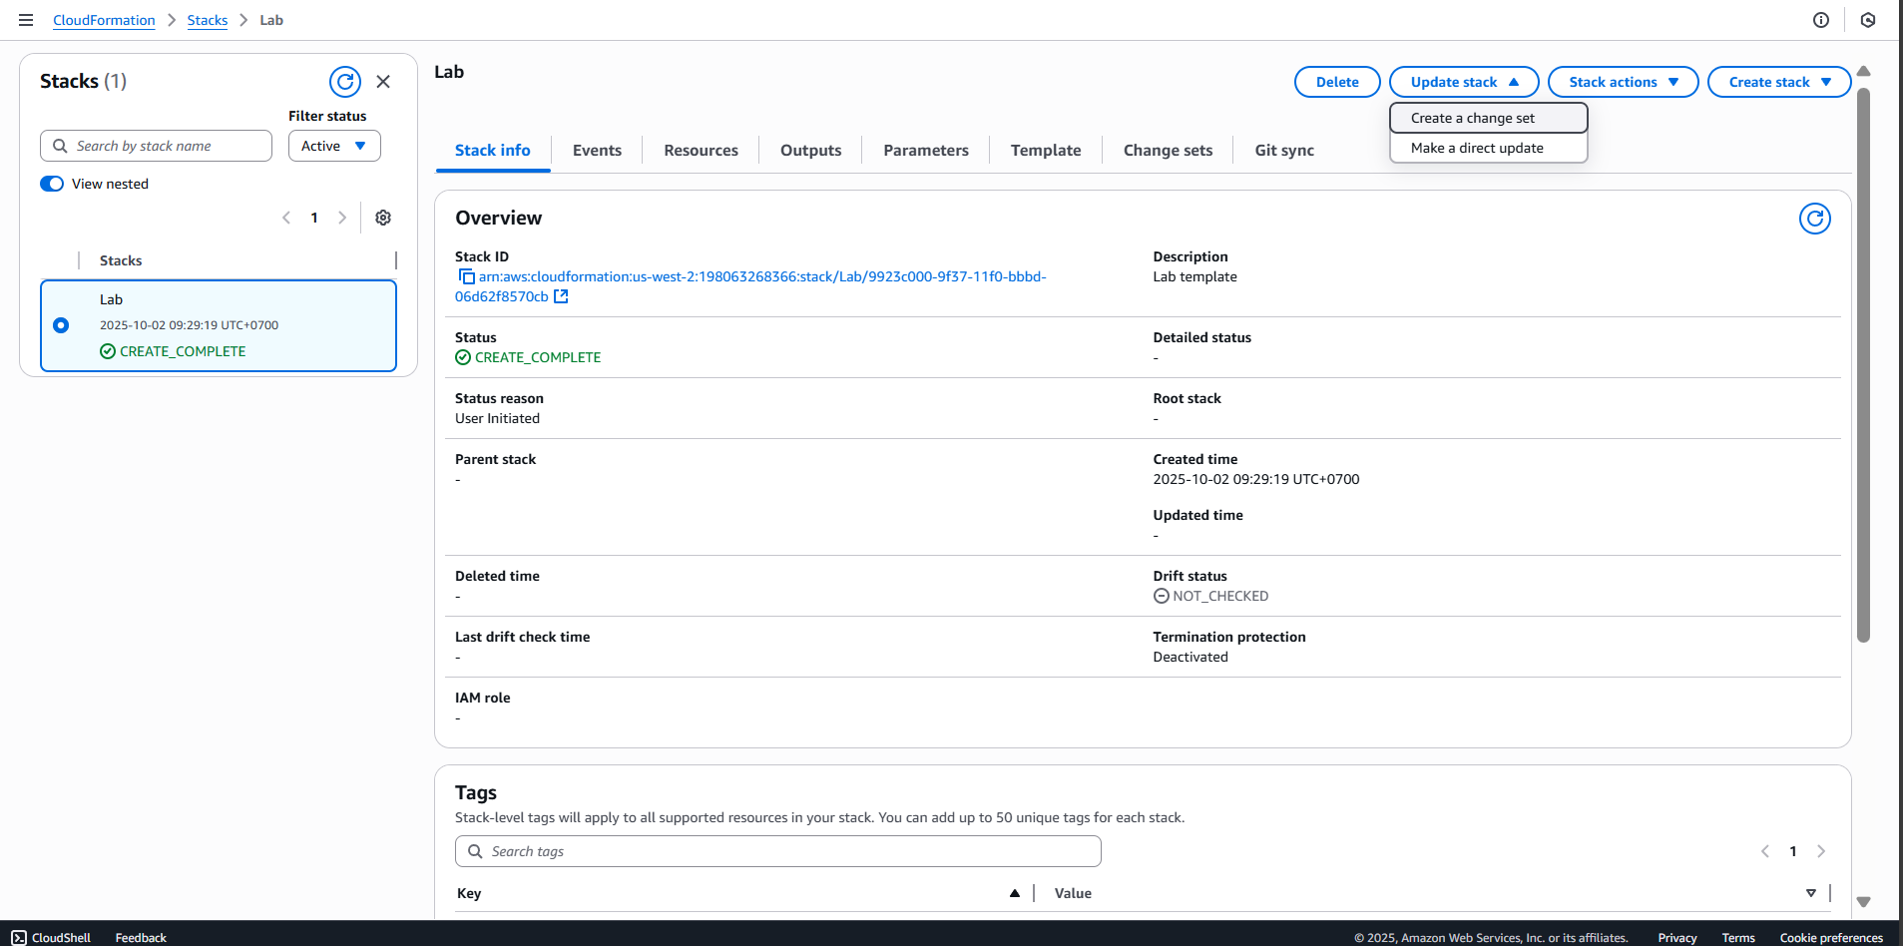
AWSTemplateFormatVersion: 2010-09-09
Resources:
S3Bucket:
Type: 'AWS::S3::Bucket'
Properties:
PublicAccessBlockConfiguration:
BlockPublicAcls: false
BlockPublicPolicy: false
IgnorePublicAcls: false
RestrictPublicBuckets: false
WebsiteConfiguration:
IndexDocument: index.html
ErrorDocument: error.html
DeletionPolicy: Retain
UpdateReplacePolicy: Retain
BucketPolicy:
Type: 'AWS::S3::BucketPolicy'
Properties:
PolicyDocument:
Id: MyPolicy
Version: 2012-10-17
Statement:
- Sid: PublicReadForGetBucketObjects
Effect: Allow
Principal: '*'
Action: 's3:GetObject'
Resource: !Join
- ''
- - 'arn:aws:s3:::'
- !Ref S3Bucket
- /*
Bucket: !Ref S3Bucket
Outputs:
WebsiteURL:
Value: !GetAtt
- S3Bucket
- WebsiteURL
Description: URL for website hosted on S3
S3BucketSecureURL:
Value: !Join
- ''
- - 'https://'
- !GetAtt
- S3Bucket
- DomainName
Description: Name of S3 bucket to hold website content

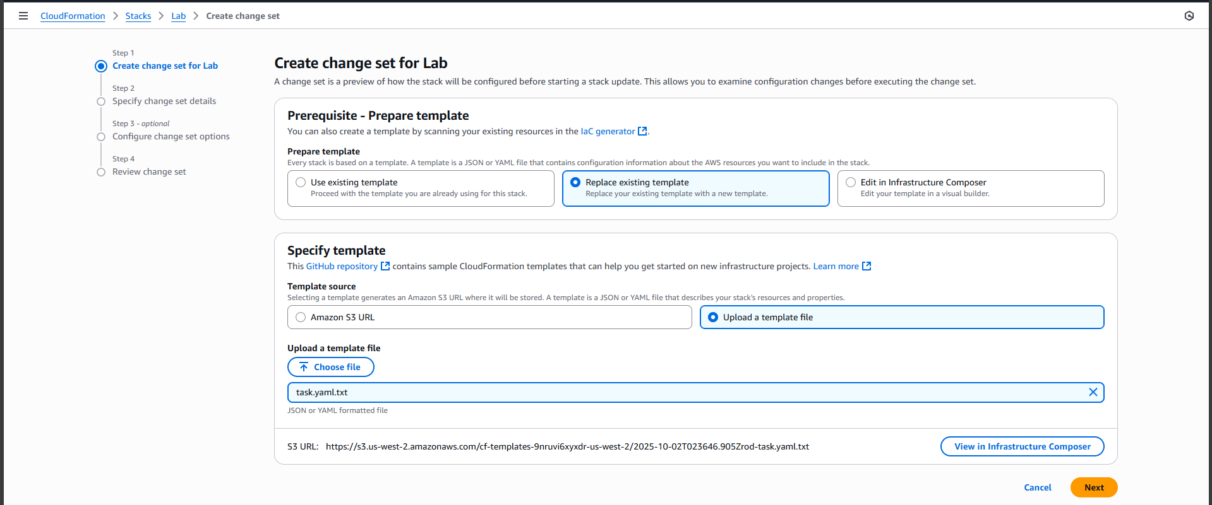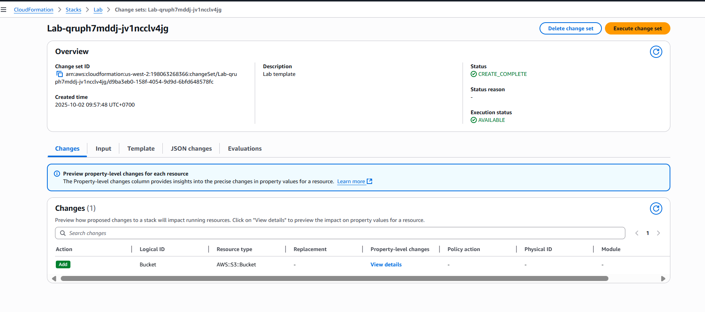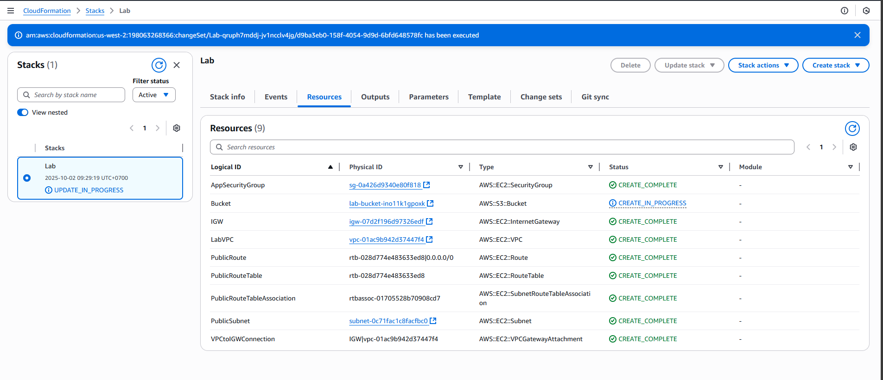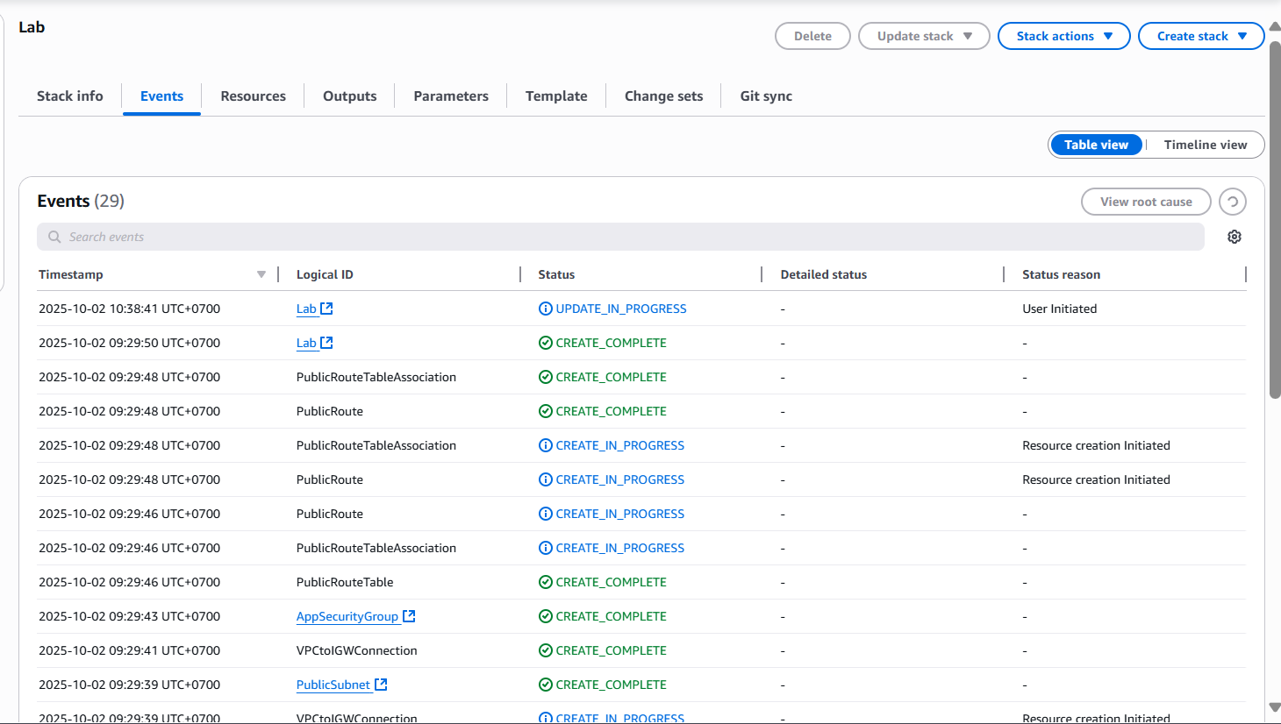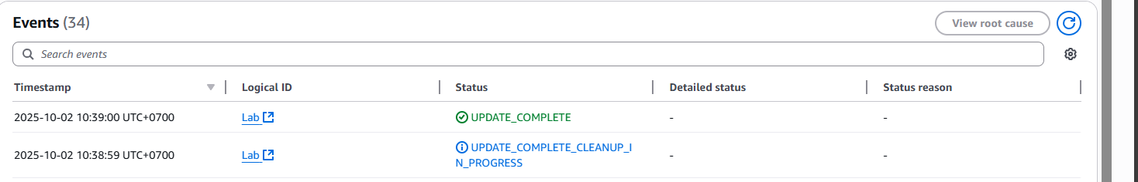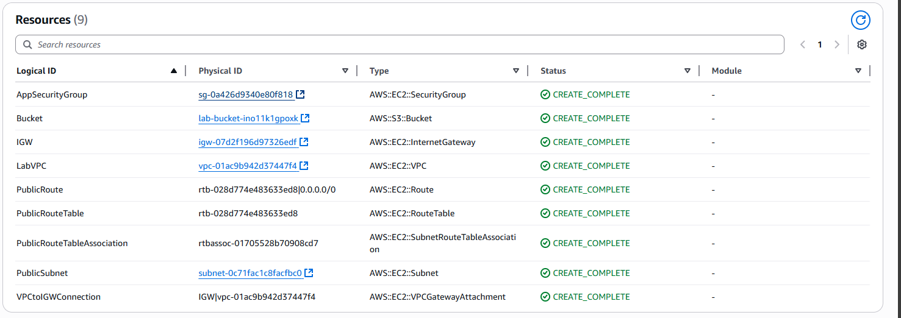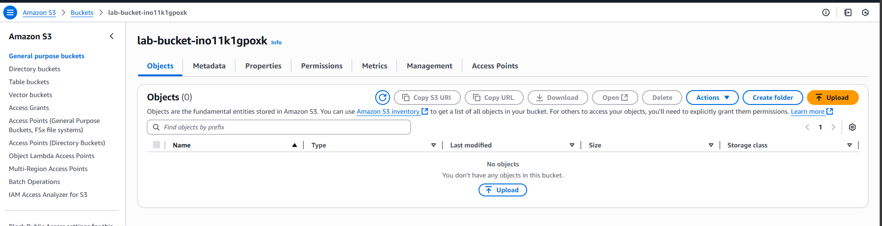
Task 3: Add an Amazon EC2 Instance to the Stack
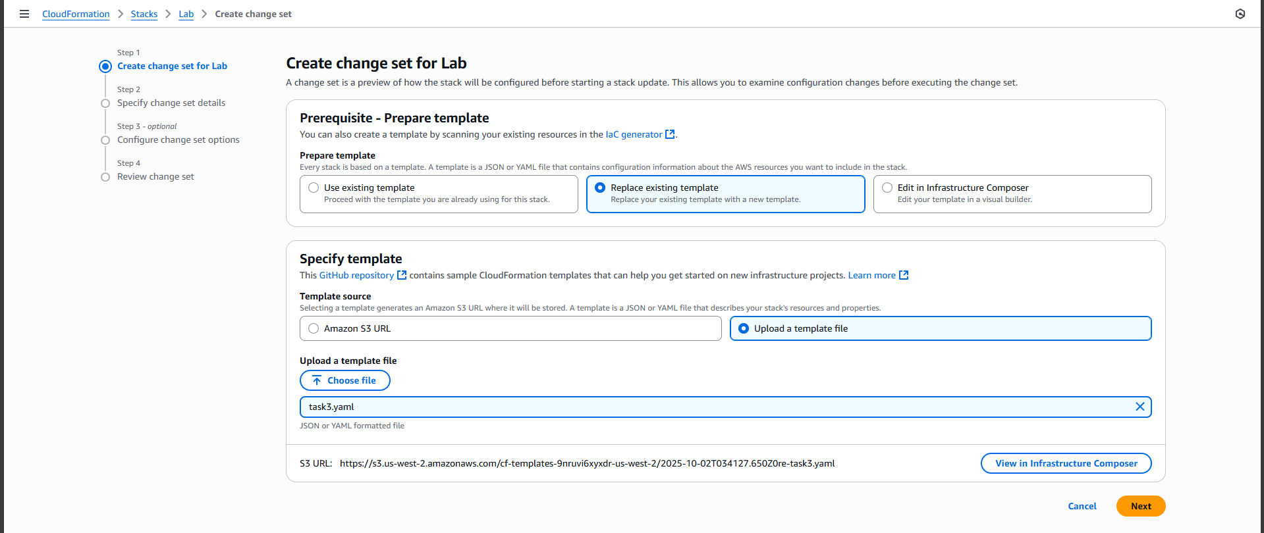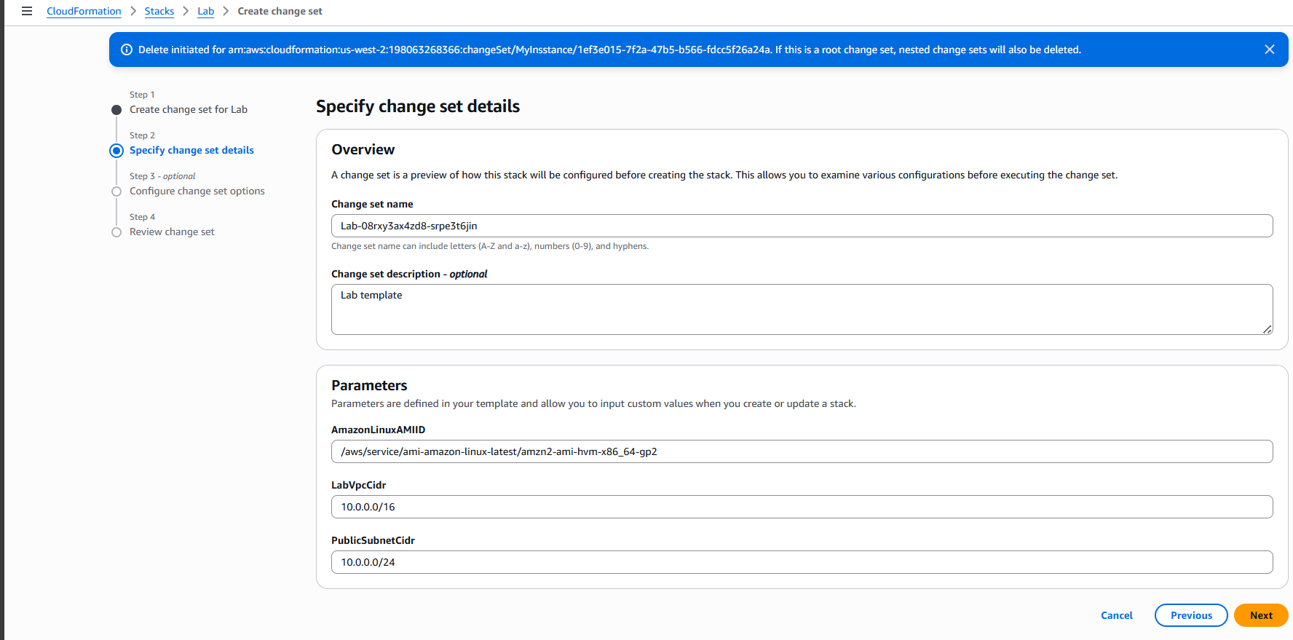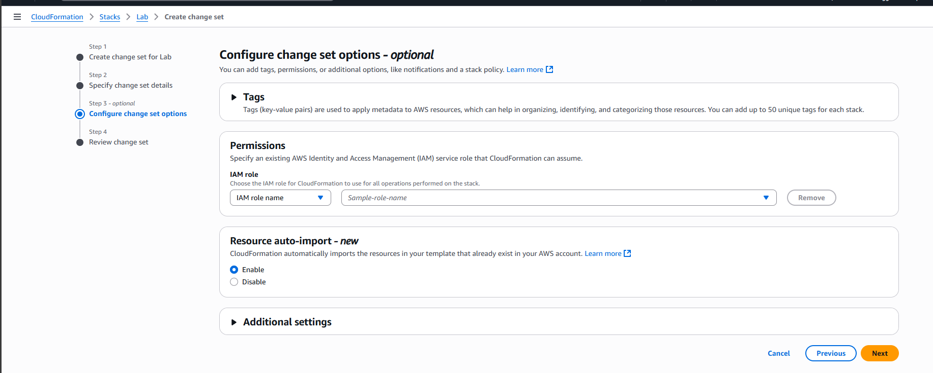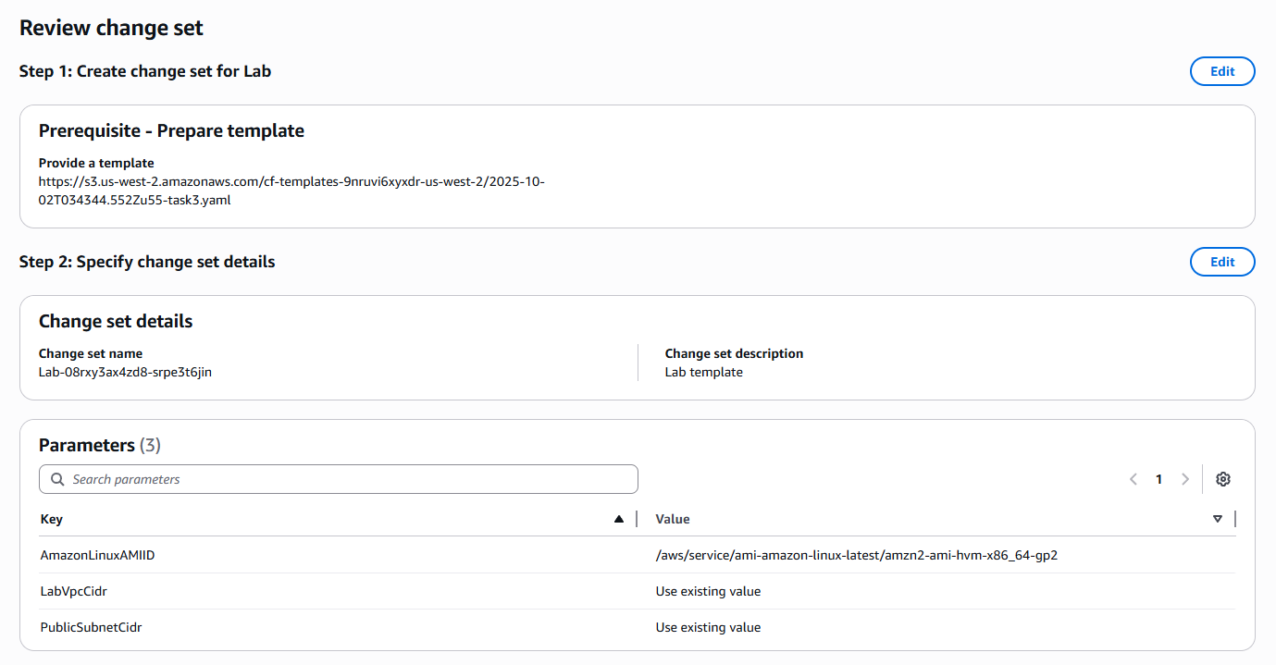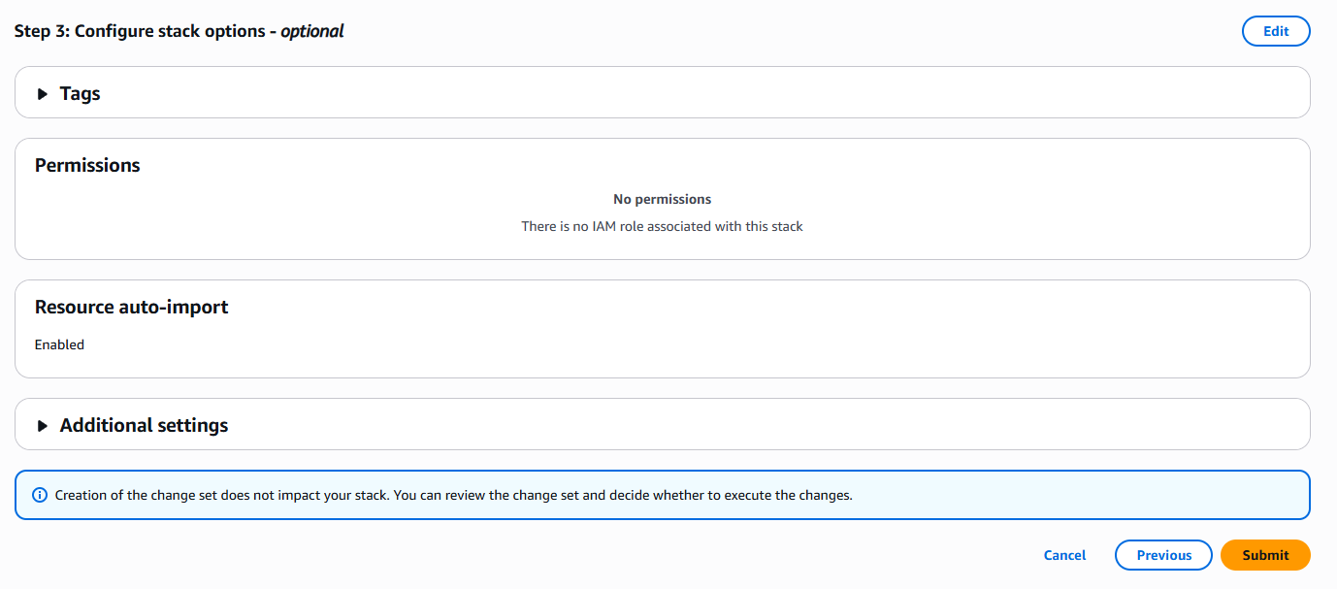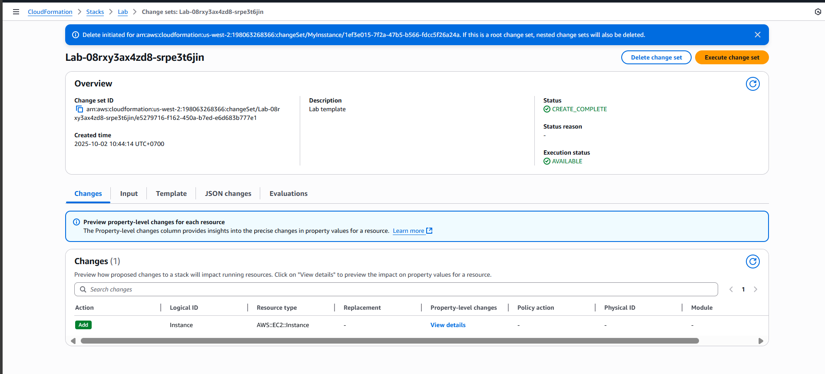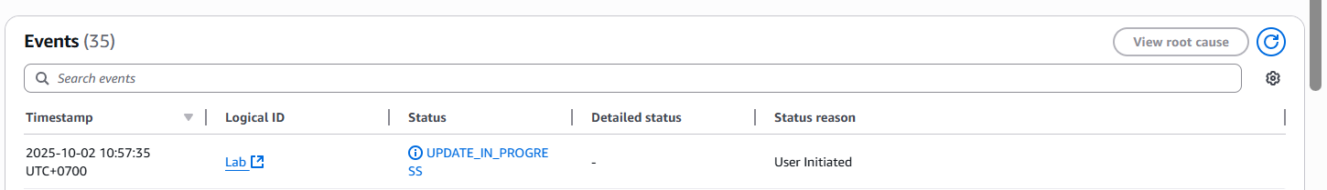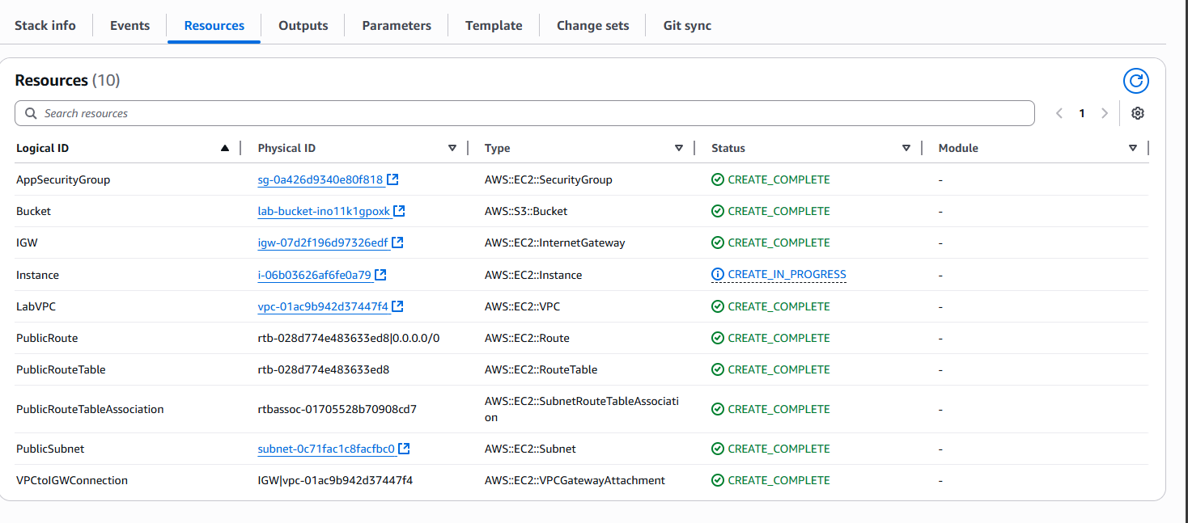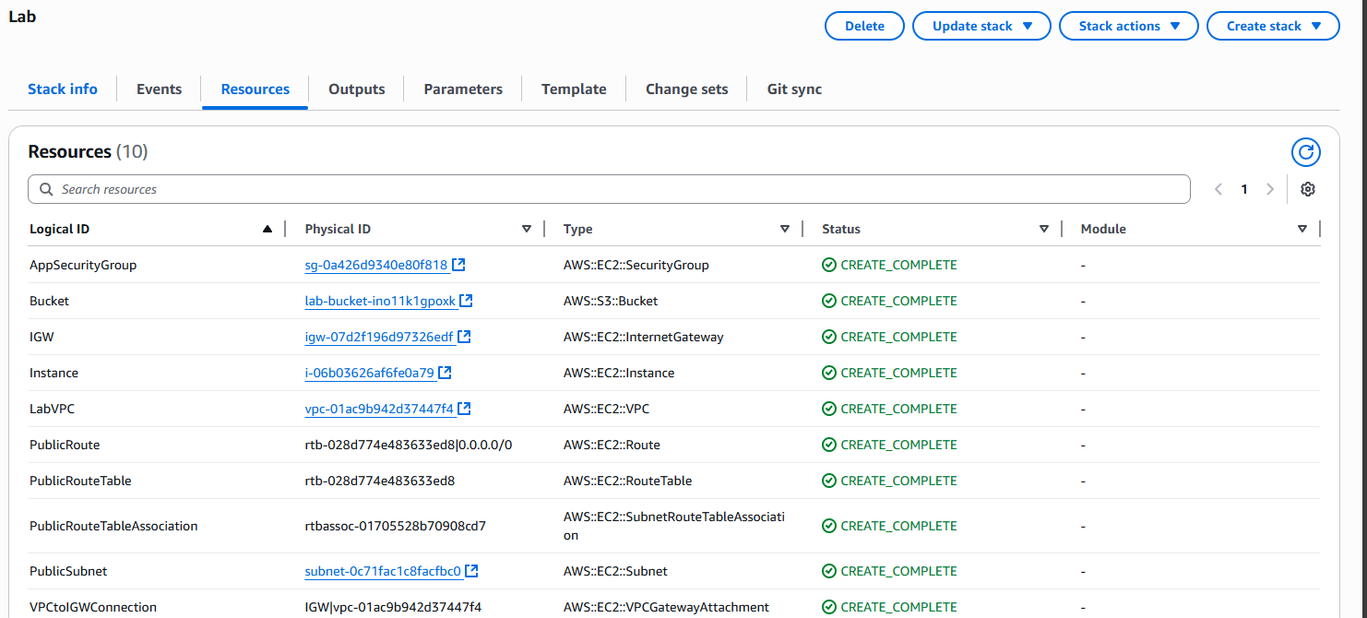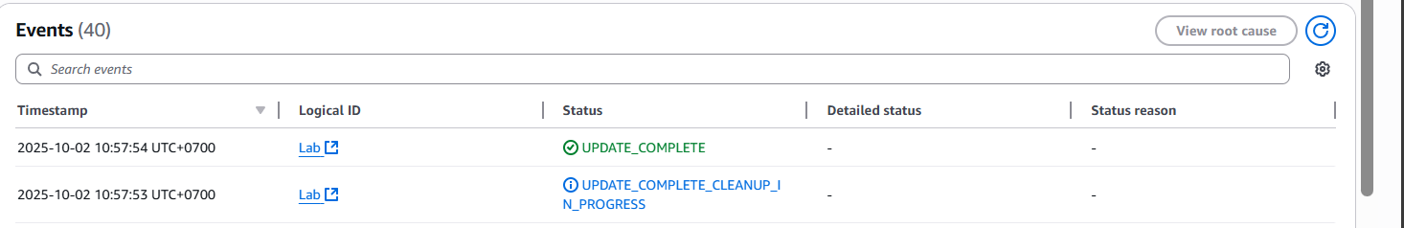
Instance created
Task 4: Delete the Stack
